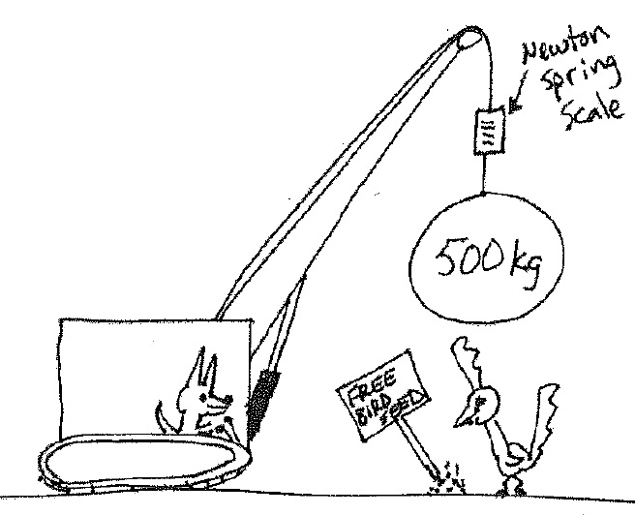
- A persistent coyote is trying to drop a wrecking ball on a pesky roadrunner! If the mass of the wrecking ball is 500. kg and it is hung from a spring scale what does the scale read when the wrecking ball:
  - … is at rest
  - … is accelerating downwards at 2.00 ${ m}/{s^{2}}$
  - … is accelerating upwards at 2.00 ${ m}/{s^{2}}$
  - … is being lifted at a constant rate of 1.00${ m}/s$
  - … is being lowered at a constant rate of 1.00${ m}/s$
- A 20.0 kg rock is sitting on a bathroom scale in an elevator. Fill in the blanks for the following statements, but be sure to show all of your work completely!
  - The scale reads N to cause an upward acceleration* 2.00 ${ m}/{s^{2}}$
  - The scale reads N to cause an downward acceleration* 2.00 ${ m}/{s^{2}}$
*doesn’t indicate the direction of movement of the elevator!

- Jack and Jill have identical cars. Both have a mass of 60.0 kg and both are driving at 20.0${ m}/s$ when they collide with identical brick walls.

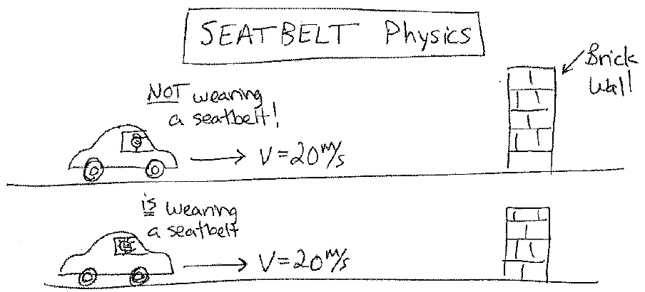
Jack is not wearing a seatbelt, but Jill is. If it takes Jill 0.10 seconds to stop during the crash, but it only takes Jack 0.010 seconds, compare the forces of impact they experience.

- A 2009 Mazda CX-7 and a 1970 Ford Galaxie 500 collide with a wall with an initial velocity of 20. $m/s$. The 2500 kg CX-7 has a crumple distance of 1.0 m during the crash. The 2500 kg Ford has a crumple distance of 0.20 m. Compare the force of impact on both cars during the crash.

- A 0.50 g leaf falls to the ground at a constant downward velocity of 1.00${ m}/s$.
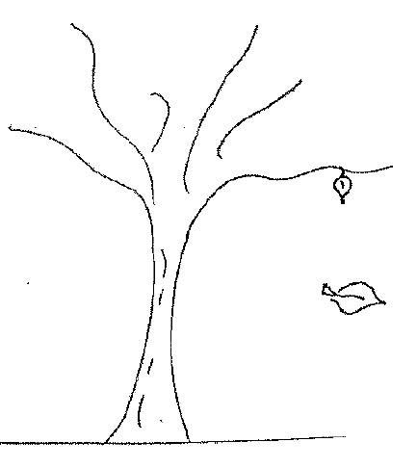

  - Calculate the upward force of air drag acting on the leaf.
  - Draw a quantitative FBD of the leaf.

