Name ____________

LAB Energy in a Coil Spring
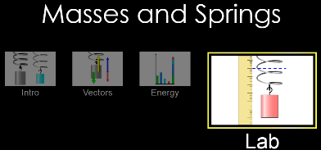
Goals: 1. Experimentally determine k, the spring constant,
2. Show that the energy stored in a spring ( ½kx²) = change in gravitational potential energy.
Part I Determine the spring constant, k, of your spring.
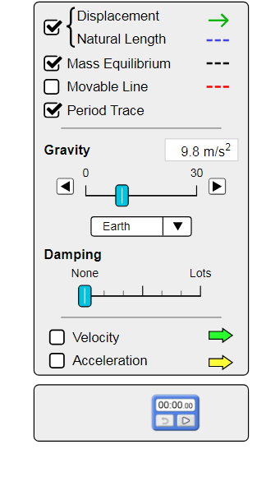
- Run the PhET simulation Springs and Masses
and select LAB, as highlighted (right)
- Turn Damping “ON” and use a ruler to measure the stretch of the spring for various known masses once the mass comes to equilibrium.
- Graph this data and determine the best-fit equation. The slope of the line, F= -kx, is the spring constant. (Note: k must be a positive value.)
Spring constant

k=________
Part II Conservation of Energy
- Turn Damping “OFF”, Displacement “ON”,
Mass Equilibrium” “ON” and Period Trace “ON”.
- Pause the simulation and place a mass on the spring (somewhere just BELOW the zero stretch position)
- Use the ruler to record this position (initial stretch of the spring).
- Turn Pause “OFF” to release the mass.
- Pause the simulation after a full cycle is “traced” and record:
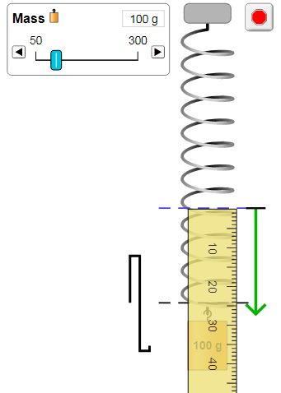
- Highest position (=initial position) pos= _________
- Change in height (=size of “trace”) Δh=__________
- x₁=initial position x₁= __________
- x₂=initial pos. + change in height. x₂= __________
U_{initial}= 1/2 kx₁² U_{final} = 1/2 kx₂² U_{gravity} = mgΔh
Part III Energy Balance: Show that the work done in stretching a
spring = change in gravitational P.E.
- Draw a GOOD picture of test set-up, labeling each position.
- On your graph, show the top and bottom positions.
- Measure the area under the curve to determine the change in spring energy.
- For Calc students, ∫Fdx=Work. Carry out the integral and see if it works.
- Compare Spring Energy to mgΔh
- Present the energy balance clearly laid out, showing the names of each
type of energy, the terms used to represent each type of energy,
as well as the measured quantities used in each term.
mgΔh = ½k (x₂)² - ½k (x₁)²
- Determine % error for this trial
- Repeat for a second trial.
- Comment on your findings.

