- Define the following (conceptual definition and equation):

  - Momentum
  - Impulse
  - Conservation of Momentum
  - Kinetic Energy
  - Potential Energy
  - Mechanical Energy
  - Conservation of Energy
  - Elastic Collision
  - Inelastic Collision

- What is the kinetic energy for the following objects?
  - A 65 kg runner moving with a speed of 7.0 $m/s$
  - A 2.0 million kg space shuttle with a launch speed of 44 $m/s$
  - A 5.0 kg bowling ball moving with a speed of 9.5 $m/s$
  - A 75 kg skier at rest

- What is the potential energy for the following objects?
  - A 0.50 kg orange sitting on a shelf 2.0 meters off the ground
  - A 68 kg snowboarder sitting on a ramp 15 meters high
  - A 1200 kg car parked in a garage 6 stories up (21 meters)
  - A 16 kg box sitting on the floor

- You decide to apply your vast knowledge of physics to baseball. You swing the bat and, oops, it’s a pop up. The .145 kg ball starts straight up off the bat at 35 m/s.
  - How much kinetic energy does the ball have initially? At the top?
  - At the top, what is the ball’s potential energy?
  - The catcher catches the ball. Just before it hits, what is the ball’s kinetic energy? Potential energy?

- You go next door from the baseball field and find the local pool. You climb up onto the 10 m platform to take a dive. If your mass is 50 kg:
  - What is the change in potential energy when you climb up there?
  - You jump. How fast are you going just before striking the water 10 m below?

- A world-class Olympic athlete starts from rest on top of a 100-meter hill, skis down the incline and makes a world-record setting jump. If she has a mass of 55 kg, use the information given in the diagram to fill in the missing information.
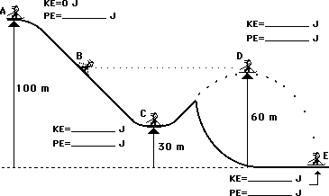
KE = 22,000 J
h = __________ m
Point A
Point D
Point C
Point D
Point E

  - Calculate her velocity at points B and C

- Use the law of conservation of energy to fill in the blanks at the various marked positions for a 1000 kg roller coaster car.
