Purpose: To investigate the conservation of energy for an object, as well as determining the relationship between potential and kinetic energies at various positions.
Materials:

- Physics Stand with Roller Coaster Track
- Photogate Timer
- Steel Marble
- Electronic Scale
- Vernier Calipers
- Meter Stick

Important Equations:

$$E_{K}=\frac{1}{2}mv^{2}$$
$$E_{p}=mgh$$

$$Total Mechanical Energy=E_{K}+E_{P}$$
Procedure:
- STOP! Did you complete the pre-lab and get it stamped? If not, you need to finish before you can start this lab.
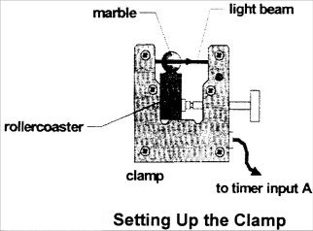
- Place the roller coaster in the 5th hole from the bottom of your physics stand using the blue/black knob.
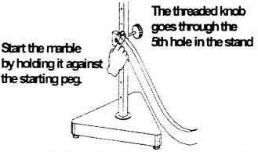

- We will be using only one of the photo gates, set on interval mode. For the initial position (x = 0.00 m) place the photogate 5.0 cm from the starting peg at the top of the roller coaster. Make sure the bottom of the photo gate is flush with the track so the marble will pass through the beam.
- Measure the diameter and mass of your marble and record these measurements in your raw data table on a separate sheet of paper.
- Place the marble against the starting peg and allow the marble to roll down the roller coaster without pushing it. Record the position along the track, the height from lab table, and time through photogate A in your data table. Perform 3 time trials at this position. Make sure that you are measuring height consistently by measuring to the position of the photogate beam each time. Record 2 height trials at each position.
- Move the photogate 10.0 cm according to the scale printed on the roller coaster track. (If your track doesn’t have a printed scale, use a flexible tape measure to measure the next position.
- Make position, height, and time measurements along the full length of the rollercoaster track. Perform 3 trials at each position of the clamp. (FYI: There should be at least 12 positions of the photogate; if the above method doesn’t yield 12 data points, go back and take data halfway in between previous points)
Data Processing (Completed INDIVIDUALLY):
- Calculate the average time through the photogate, average height and the velocity of the marble at each position along the track. Also convert measurements to the correct units for your calculations. Record your results in a second data table, remembering to include position along the track as well.

- Now calculate the potential energy, kinetic energy, and total mechanical energy at each position along the track. Record you results in a third data table, remembering to include position along the track as well.

- Create one graph to show the relationship between distance traveled along the track (position on the x-axis) and the energy of the steel marble. Potential, kinetic, and total mechanical will all be plotted on a single graph!)

- On you graph, fit the mechanical energy data with a linear best fit line. Fit both kinetic and potential energy with their own best fit curve (not linear, find something that follows the trend of the data!)
Analysis Questions (Completed INDIVIDUALLY):
- Discuss and analyze your graph:
  - What do your results suggest about the conservation of energy for this lab?
  - What do your results suggest about the relationship between potential and kinetic energy?

- Determine what percentage of your total mechanical energy was lost using the following equation:
$$\% \text{Lost}=\frac{{ME}_{initial}-{ME}_{final}}{{ME}_{initial}}×100\%$$

- What could account for the “loss” of mechanical energy in this lab?

Final Lab Write-up Requirements:
- Pre- and Post-Lab Handouts
- Include 1 hand drawn raw data table
- Include 3 computer processed tables: 1 raw data table and 2 tables of calculated values (#1+2)
- Include one graph with 3 lines plotted (#3+4)
- Answers to analysis questions #1-3
- Use the rubric to double check you lab report!

