Na Grembowski
Partner: Lisa Gutcher
Rollercoaster Conservation of Energy Lab
Table 1: Position, Height, Time of a Marble through a Photogate on a Rollercoaster Track
Position Along Track  (± 0.1 cm) | Height from Lab Table  (± 0.05 cm) | Time through Photogate  (± 0.0002 s)
 |  | Trial 1 | Trial 2 | Trial 3
5.0
15.0
25.0
35.0
45.0
55.0
65.0
75.0
85.0
95.0
105.0
115.0
125.0
Diameter of marble: …………….± 0.003 cm
Mass of the marble: ……….. ± 0.01 g

Table 2: Average Time through Photogate and Velocity of a Marble on a Roller Coaster Track
Position Along the Track  (cm) | Height from Lab Table  (m) | Average Time through Photogate  (s) | Velocity of Marble through Photogate A  $$\left(m/s\right)$$
5.0
15.0
25.0
35.0
45.0
55.0
65.0
75.0
85.0
95.0
105.0
115.0
125.0
- Sample Calculation for Conversion of Height into Meters at 5 cm along the track:

36.68 cm 1 m
100 cm = 0.3668 m

- Sample Calculation for the Average Time through Photogate A for 5 cm along the track:

$${Time}_{avg}=\frac{{Time}_{1}+{Time}_{2}+{Time}_{2}}{3}$$
$${Time}_{avg}=\frac{0.0570s+0.0570s+0.0566s}{3}$$
$${Time}_{avg}=\frac{0.1706 s}{3}$$

$\boxed{{Time}_{avg}=0.0569 s}$

- Sample Calculation for Diameter of Marble into Meters:

1.910 cm 1m
100 cm = 0.01910 cm

- Sample Calculation for the Velocity of the Marble at 5cm along the Track:
$$V_{inst}=\frac{∆d}{∆t}$$

$$V_{inst}= \frac{Diameter of Marble (m)}{Avg Time Through Gate A(s)}$$

$$V_{inst}= \frac{0.01910 m}{0.0569s}$$

$$\boxed{V_{inst}=0.336 m/s}$$

Table 3: Kinetic, Potential, and Mechanical Energies of a Marble on a Rollercoaster Track
Position Along Track  (cm) | Height from Lab Table  (m) | Kinetic Energy  (J) | Potential Energy  (J) | Total Mechanical Energy  (J)
5.0
15.0
25.0
35.0
45.0
55.0
65.0
75.0
85.0
95.0
105.0
115.0
125.0

- Sample Calculation for conversion of mass of marble into kilograms:

28.17 g 1 kg
1000 g = 0.02817 kg

- Sample Calculation for Kinetic Energy of the marble at 5 cm along the track:
$$E_{k}= \frac{1}{2}mv^{2}$$
$$E_{k}= \frac{1}{2}(0.02817 kg){(0.336}^{2})$$
$$\boxed{E_{k}= 0.00159 J}$$

- Sample Calculation for Potential Energy of the marble at 5 cm along the track:
$$E_{p}=mgh$$
$$E_{p}=\left(0.02817 kg\right)\left(9.80 {\frac{m}{s}}^{2}\right)(0.3668 m)$$
$$\boxed{E_{p}=0.1013 J}$$

- Sample Calculation for Mechanical Energy of the marble at 5 cm along the track:
$$Total Mechanical Energy=E_{k}+E_{p}$$
$$Total Mechanical Energy=0.00159 J+0.1013 J$$
$$\boxed{Total Mechanical Energy=0.1029 J}$$
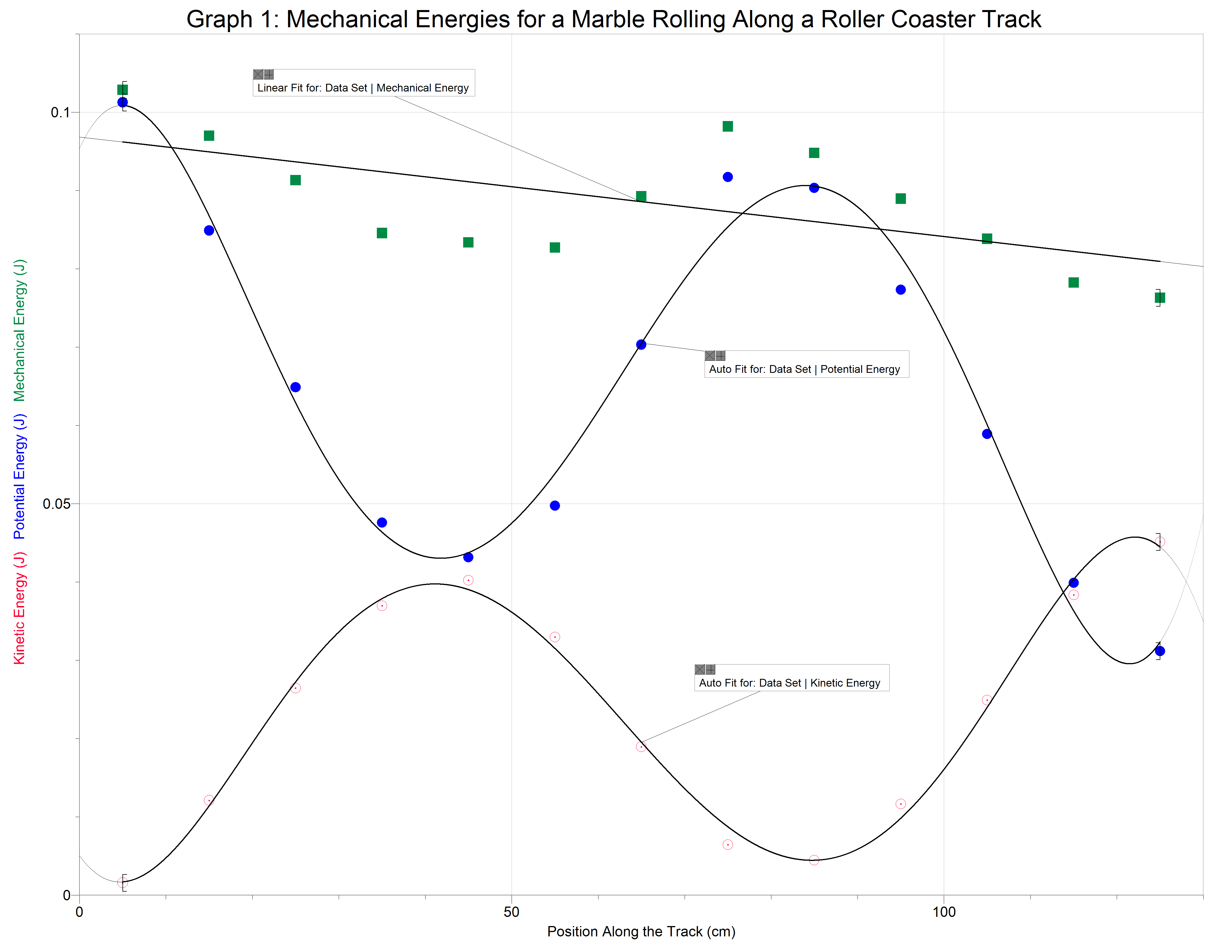

Analysis Questions:
1.
- This lab shows that the total mechanical energy was not exactly conserved. If the total mechanical energy was conserved, the graph would have a straight, flat line, as it would not change. However, the line is curvy, meaning that some mechanical energy was lost due to the marble spinning and the sound of the marble on the track.
- The graph shows that as potential energy increases, kinetic energy decreases. As kinetic energy increases, potential energy decreases. They share an inversely proportional relationship.
2.
$$\% Lost=\frac{ME Initial -ME Final}{ME Initial} ×100$$
$$\% Lost=\frac{0.1029 J-0.0763J}{0.1029 J} ×100$$
$$\boxed{\% Lost=25.9\%}$$

3. The main thing that accounts for the apparent "loss" of the mechanical energy of the lab is the marble spinning and rotating rather than sliding along the track. Other things that could account for the loss of mechanical energy are the sound and friction of the marble rolling on the track.

