- Define the Doppler Effect. How does the apparent frequency for sound waves shift for an observer based on the motion of the source? How does this differ from the Doppler Effect for light waves?
The Doppler Shift is the APPARENT shift in frequency/wavelength due to the relative motion of a sound source to an observer.
When a sound source is moving TOWARDS the observer, the pitch the observer hears will be HIGHER than the source frequency and vice versa!
When a light source is moving TOWARDS the observer, the wavelength the observer sees will be SHORTER than the source frequency, thus the light is BLUE SHIFTED; and vice versa!

- Define and each of the following wave behaviors and provide examples from mechanical waves, sound waves, and EM waves (such as light):

  - Interference: Interference is a result of the superposition principle which states that waves can be in the same place at the same time. Constructive interference means that a wave with larger amplitude is produced; destructive interference means that a wave with small amplitude (or even 0!) is produced. We saw a mechanical wave example of this in the ripple tank demos. In sound waves, interference patterns create beat frequencies. In light waves, interference patterns in Young’s double slit experiment showed that light has wave properties.

  - Transmission: Transmission occurs when some or all waves pass through a material. We saw a mechanical wave example of this in the ripple tank demo #2. An example from sound would be hearing voices from a neighboring room through the wall. An example from light would be light passing through tissue paper.

  - Absorption: Absorption occurs when part or all of a wave is blocked by a barrier. This occurs in sound proofing for some frequencies of sound. In light, an example would be subtractive color mixing; i.e. – a red rose absorbs all frequencies of light except for red.

  - Reflection: Reflection is the redirection of waves back into the same part of the medium they came from as a result of interaction with a barrier or medium change. We saw a mechanical wave example of this in the ripple tank experiment #1. In sound, this can be seen with echoes. In light, spectral reflection, such as with a mirror, reflects light rays parallel to each other. In diffuse reflection, light is scattered and thus has a halo of light, rather than a beam.

  - Refraction: Refraction is the bending of waves when they enter a new medium. We saw a mechanical wave example of this in the ripple tank experiment #2. In sound, we experience refraction with different temperatures of air. In light, we see refraction when mediums are changed according to Snell’s law; this is also the reason that prisms can break white light down into the visible spectrum.

  - Diffraction: Diffraction is the bending of wave fronts into an open part of a medium and around corners of barriers. We saw a mechanical wave example of this in the ripple tank experiment #3. In sound waves, hearing someone around a corner is an example of diffraction. In light waves, light diffracts around clouds, creating some very cool patterns!

- What is a beat frequency? Why is the pattern of beats produced?
A beat frequency is produced by sound wave interference. Repeating patterns of constructive and destructive interference when two sources have different frequencies create a pattern of loud and soft “beats.” The number of beats per second is called the beat frequency and is equal to the difference in frequency of the two sources.

  - A tuning fork has a frequency of 465 Hz. When a second tuning fork is struck, beat interference patterns occur with a beat frequency of 5 Hz. What is the lowest and highest frequency of the second fork?
LOWEST FREQUENCY: 465Hz – 5Hz = 460 Hz
HIGHEST FREQUENCY: 465Hz + 5Hz= 470 Hz

- What is a standing wave and how is it created? What are nodes and anti-nodes?
A standing wave is created when a wave reflects back on itself. Constructive interference creates areas of maximum displacement called nodes and destructive interference created anti-nodes which remain stationary.

  - Sketch standing waves in a string for the first 4 harmonics. What general equation can be applied to standing waves in a string?
$$L=\frac{n∙λ}{2}$$

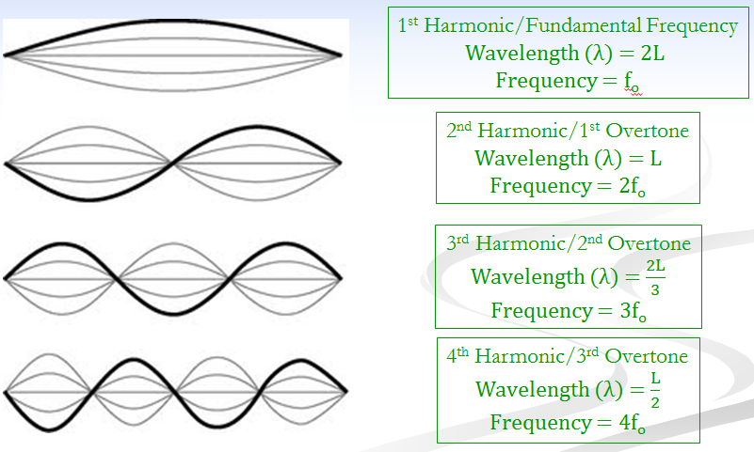

- Sketch standing waves in an open-end resonator for the first 4 harmonics. What general equation can be applied to standing waves in a string?
$$L=\frac{n∙λ}{2}$$

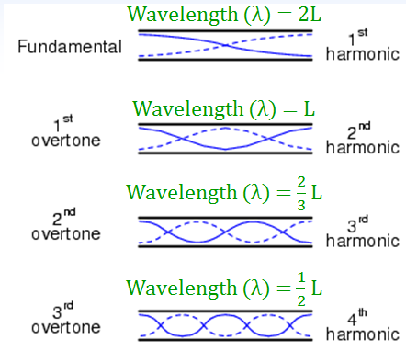

  - A flute acts as an open-end resonator. If the flute has a resonant length of 25 cm, what is the wavelength of the 3rd harmonic frequency?
$$L=\frac{n∙λ}{2}↝λ=\frac{2∙L}{n}=\frac{2(0.25m)}{3}$$
$$\boxed{λ=0.17 m}$$

- Sketch standing waves in a closed-end resonator for the first 4 harmonics. What general equation can be applied to standing waves in a string?
$$L=\frac{n∙λ}{4}$$

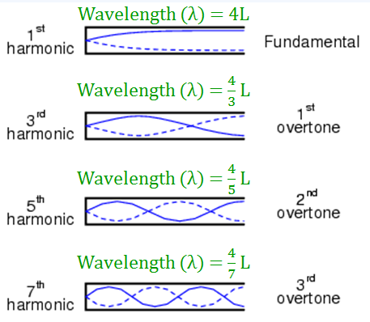

  - An organ pipe acts as a closed-end resonator. What is the length of an organ pipe which has a fundamental frequency of 18 Hz?
$$v=fλ↝λ=\frac{v}{f}=\frac{343 m/s}{18 Hz}=19 m$$
$$L=\frac{n∙λ}{4}=\frac{1(19 m)}{4}$$
$$\boxed{L=4.8 m}$$

- What is an EM Wave? What is the Electromagnetic Spectrum? How is it laid out in terms of frequency, wavelength, and energy?
An electromagnetic wave is a caused by simultaneous oscillations in the electric and magnetic fields. It is a 2 dimensional transverse wave. The EM spectrum organizes different types of EM waves from longest to shortest wavelengths. Waves are also arranged in order from lowest to highest energy and frequencies.

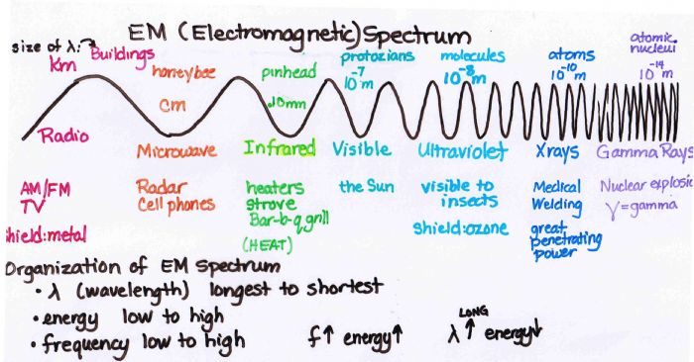

- List applications of the following types of EM waves:

  - Gamma Rays: nuclear reaction product, cancer treatment, sterilization
  - X-Rays: medical imaging, airport security, deep space telescopes
  - Ultraviolet Rays: tanning, forgery prevention, sterilization
  - Visible Light: eyes, lasers, technology such as CD and DVD players, printers
  - Infrared Radiation: remote controls, healing injuries, thermal imaging
  - Microwaves: cooking, cell phones, radar, speed cameras
  - Radio Waves: communication

- Explain Snell’s Law and index of refraction.
Snell’s law is the law of refraction for light waves. The index of refraction is a property of a medium that affects the angle of refraction.
  - List the equations for each and explain each of the variables.
$$n_{1}\sin{θ_{1}}=n_{2}\sin{θ_{2}}$$

Where n₁ is the index of refraction in the incident medium,θ₁ is the incident angle, n₂ is the index of refraction in the refractive medium, and θ₂ is the refractive angle.

$$n=\frac{c}{v}$$

Where n is the index of refraction, c is the speed of light, and v is the speed of light in the medium for which we are determining the index of refraction.

  - A beam of light passes from water into glass. The index of refraction for water (n_{water}) is 1.33 and the angle of incidence is 25°. If the angle of refraction is 22°, what is the index of refraction for glass?
$$n_{1}\sin{θ_{1}}=n_{2}\sin{θ_{2}}↝n_{2}=\frac{n_{1}\sin{θ_{1}}}{\sin{θ_{2}}}=\frac{1.33\sin{25°}}{\sin{22°}}$$

$$\boxed{n_{2}=1.52}$$

- Define total internal reflection.
Total internal reflection occurs when light falls on a surface of a less optically dense medium at an angle of incidence equal to or greater than the critical angle of the substance. There is no refracted ray; occurs at critical angle.

  - What is the critical angle and how does it relate to total internal reflection?
The critical angle is the angle of incidence in the more optically dense medium at which the angle of refraction in the less optically dense medium is exactly 90°. If the incident angle of an incoming light beam is greater than the critical angle, total internal reflection will occur.

  - What are some applications of total internal reflection?
Total internal reflection is used in fiber optic technology and binoculars.

- What is the range of the visible spectrum?
400 (violet) – 700 nm (red)
  - What colors do we typically say make up the visible spectrum?
ROYGBIV
  - Is white a color of light? Why or why not?
NO! White light is the presence of all color of the visible spectrum.
  - Why are sunsets red? Why is the sky blue?
Sunsets are red because red wavelengths of light survive being scattered by the air before reaching our eyes. The sky is blue because blue wavelengths of light are scattered by the air molecules, so when we look up, we see all the scattered blue light!

- How can we use prisms to prove white light is made up of all the visible colors of light? What is dispersion?
Prisms break white light into the visible spectrum. They do this using refraction and dispersion. Dispersion is a phenomenon in which the angle of refraction depends on the wavelength of light. This means that different colors of light bend at different angles, thus creating the visible spectrum.

- Draw and label a diagram for both additive and subtractive color mixing.

Additive Color Mixing Subtractive Color Mixing
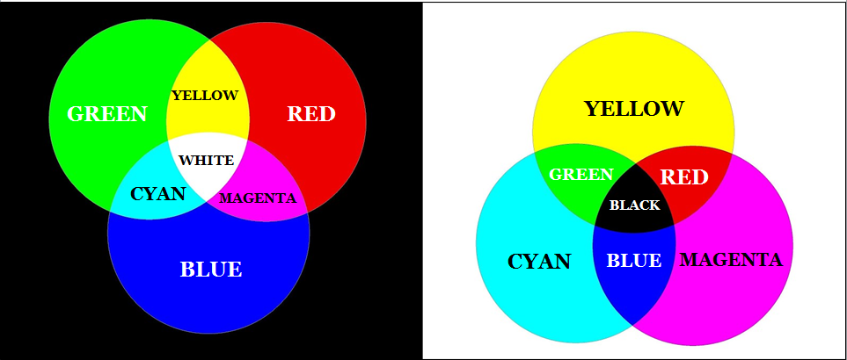

  - What are examples of additive color mixing? Subtractive color mixing?
Additive color mixing applies to light and our eyes. Subtractive color mixing happens with colored pigments, inks, and dyes.

  - What are the primary, secondary, and complementary colors of light?
The primary colors of light are red, blue, and green.
The secondary colors of light are cyan, yellow, and magenta.
The complementary colors are blue and yellow; green and magenta; & red and cyan.

  - What are the primary and secondary colors of ink/pigment?
The primary colors of pigment/ink are cyan, yellow, and magenta.
The secondary colors of pigment/ink are red, blue, and green.

  - Is black a color of light? Why or why not?
Black is a lack of color/light! Thus it is not a color at all.

  - If you shine a red flashlight and a blue flashlight at a white wall, what color will you see where the flashlight beams overlap?
This is additive color mixing: red + blue = MAGENTA light

  - What color is a yellow ball when viewed under cyan light?
The ball is yellow because of subtractive color mixing: blue light is subtracted/absorbed. We see yellow light because of additive color mixing: green and red light are reflected. Cyan light is a mixture of blue and green light; since blue is absorbed, we will see the ball as GREEN.

- You decide to kick off your summer with a relaxing cruise around Lake Sammamish in your friend’s boat. But a storm rolls in to ruin your fun!
  - If the temperature drops to 15.0°C, what is the speed of sound in air on the lake?
$$v_{sound}=331+0.6T=331+0.6\left(15℃\right)$$
$$\boxed{v_{sound}=34\overline{0}m/s}$$

  - You see a big flash of lightening and count 2.60 seconds before hearing the thunder. How far away is the storm?
$$v=\frac{d}{t}↝d=v∙t=(340m/s)(2.60 s)$$
$$\boxed{d=884 m}$$

  - How far did the flash of lightening travel in the 2.60 seconds it took for the sound wave from the thunder to reach you?
$$v=\frac{d}{t}↝d=v∙t=(3.00×{10}^{8}m/s)(2.60 s)$$
$$\boxed{d=780,000,000=7.80×{10}^{8} m}$$

  - If the rumble of the thunder had an average frequency of 95 Hz, what was the wavelength of the sound wave?
$$v=fλ↝λ=\frac{v}{f}=\frac{340m/s}{95 Hz}$$
$$\boxed{λ=3.58 m}$$

  - What is the period of the thunder’s sound wave?
$$f=\frac{1}{T}↝T=\frac{1}{f}=\frac{1}{95 Hz}$$
$$\boxed{T=0.0105 s=1.05×{10}^{-2}s}$$

