Introduction:
The incredible damage and tragic loss of life resulting from the 9.1 magnitude earthquake and ensuing tsunami was shocking. The event marked the most devastating natural disaster to hit the world in the last century.
While earthquakes are somewhat unpredictable, and always beyond our control, earthquake related tsunamis can be measured and predicted in time to provide some warning to residents of susceptible coastal areas, and shoreline structures can be built to withstand the force of a tsunami. And there are natural warning signs of impending tsunamis, too, that properly understood and heeded can give individuals along the shore time to get to higher ground. Unfortunately for the tens of thousands of victims of the tsunami, a warning system did not exist in the Indian Ocean Basin, most shoreline structures were not built to reduce the destruction from the force of a tsunami, and many people on the shores did not recognize or understand the warnings nature provided.

Purpose:
We will learn from this tragedy, and hopefully work to provide better warning systems, better construction, and better natural disaster preparedness education in the future.
In this lab you’ll study seismograms from 3 different seismic stations recording the magnitude 9.1 Sumatra earthquake of December 26th, 2004. By comparing the arrival times of the p- and s-waves on each seismogram, you can accurately map the location of the epicenter of the earthquake.
Once you’ve located the epicenter, you’ll calculate the position of the tsunami generated by the quake at one hour intervals. From those determinations, you will be able to predict how much time people had before the tsunami crashed onto their shores. Finally, you will investigate some of the ways people can lessen the impact of the next great tsunami.

Materials:
- Drawing compass
- 2 sets of 3 seismograms from the same earthquake (included in on pages 7, 11)
- p- and p-wave travel time curves (included on page 8)
- Maps 1 and 2 for plotting the earthquake epicenter (included on pages 9, 12)
- Tectonic map of the world (included on page 10)
- Web resources (included on page 6)
- Scrap paper for calculations

Procedure - Part 1: Finding the Distance to the Epicenter
- Using the first set of seismograms on page 7, read the time of the p- and s-waves at each station and place that information in Data Table 1. Read each arrival time to the nearest second. Note: The first vertical line marks the p-wave arrival and the second vertical line marks the s-wave arrival time.
- Devise a way to determine the amount of time that elapsed between the arrivals of the p- and s-waves at each station. One way is to subtract the p-wave arrival time from the s-wave arrival time (s-p), though there is a more direct way to get that information off the seismogram. Double check and record your results in Data Table 1.
- Use the p- and s-wave travel-time curves on page 8 to find the distance from each station to the earthquake epicenter. Do this by finding the unique epicenter distance where the difference in the p- and s-wave travel times (the space between the two curves) is exactly equal to the difference you calculated from the seismogram (column 3 in Data Table 1). Record the corresponding distance in the last column of Data Table 1.
- On the Indonesian Earthquake Map 1 on page 9, use the map scale and your compass to draw circles around each station of a radius equal to the epicenter distances that you just determined using the travel time curves.
- The intersection of the 3 circles marks the epicenter of the ‘quake. Label it “Epicenter” on Map 1.

DATA TABLE 1:
Seismograph Station | p-wave Arrival | s-wave Arrival | Time Difference | Epicenter Distance

IC.LSA
KMBO
GUMO

Part 1 Questions: Use any resources you need to answer questions below

- Which seismic station is located farthest from the epicenter?
  - How could you have determined which was farthest by simply looking the seismograms?

- The earthquake occurred on a tectonic plate boundary. Refer to the tectonic map for the following questions:
  - Between what 2 tectonic plates did this earthquake occur?

  - How are the plates moving relative to each other in the area of the earthquake?

  - What term describes this kind of plate boundary?

- The focus of the earthquake occurred about 150 km (90 mi) northeast of the surface expression of the plate boundary (see map below) and at a depth of about 30 km (18 mi).
  - Explain how this information helps you to determine which plate is being subducted.

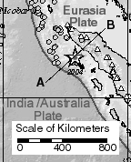

- For each station, subtract the p-wave travel time (found using the travel-time curves on page 8) from the time that the station first felt the p-wave. This will tell you when the p-wave left the epicenter which is when the earthquake actually occurred! You will need to use your reference tables to answer these questions.

Show your work here!

IC.LSA: KMBO: GUMO:

- Use a web resource from page 6 to find the actual time of the earthquake:
* Cite your source(s):
- Explain why there might be some variation among the times you’ve recorded above:

Procedure - Part 2: Locating the Epicenter of the Earthquake

Now that we have an idea where the earthquake originated, we can use three closer seismograph stations to more accurately pinpoint the location of the epicenter.

- Label the following Countries on Map 2 on page 12 (use any resources you need):
  - India, Sri Lanka, Somalia, Sumatra (Indonesia), Myanmar, Thailand,

- Follow the same procedures used in Part 1 to find the epicenter on Map 2.
  - You will need to use the second set of seismograms on page 11 from stations

DATA TABLE 2:
Seismograph Station | p-wave Arrival | s-wave Arrival | Time Difference | Epicenter Distance

PALK
DGAR
COCO

Part 2 Question:

- Why do you need at least three seismic stations to find the epicenter of the earthquake?

Procedure - Part 3: Predicting the Arrival of Tsunami Waves

The speed at which a tsunami moves through the ocean is dependent largely on the depth of the ocean. The tsunami generated by this quake moved at an average speed of about 600 kilometers per hour. Though tsunamis travel fast, their wave amplitudes are at most only a few feet. Additionally, their wavelengths are over 100 km long, so they are often unnoticed as they pass beneath ships at sea. As they approach shallow water near the coast however, tsunami waves slow down, the wavelength shortens, and heights may increase many meters.

Assume the tsunami generated by the Sumatra earthquake traveled 600 km/hr in the open ocean. On Map 2, use your compass to draw and label circles around the epicenter. You will draw a total of 4 circles showing the distance the tsunami had traveled in 1 hour, 2 hours, 3 hours, and 4 hours.

(You should have 4 labeled circles surrounding your epicenter representing the position of the leading edge of the tsunami as it traveled through the ocean after the earthquake occurred. Remember to use your compass!)

Procedure - Part 4: Speed of Seismic Waves

In Data Table 3, list the 6 seismic stations you’ve used in order of increasing distance from the epicenter.
Fill in the p-wave travel time (convert into seconds) and distance data from Tables 1 and 2. Finally calculate and record the average speed of the p-waves arriving at each station by dividing the data from columns 2 and 3.

DATA TABLE 3:
Station | Epicenter  Distance  (km) | p-Wave Travel  Time  (s) | Average Speed of  Recorded p-Waves  (km/s)

- At first glance, the results of your calculations may be surprising. How can the differences in average speed be explained? Investigate the way the seismic waves travel through the earth, and explain why the waves arriving at more distant places travel at a higher average speed.

* Cite your source(s):

Concluding Questions: Use any resources you need to answer questions below

- Investigate the number of people killed by the tsunami in the following countries:
  - India:
  - Sri Lanka:
  - Thailand:
  - Myanmar:
  - Somalia:
Total Casualties:
- Why do you suppose Indonesia’s casualty rate was so high?

- Had a warning system been in effect, would there have been time to warn Aceh (northern tip of Sumatra)?

- How might the residents of Aceh known that there was some danger of a tsunami before it actually arrived?

* Cite your source(s):

- Using Map 2 (p. 12) and the tsunami circles that you drew, estimate the amount of time that these countries had before the tsunami crashed onto their shores.
  - India:
  - Sri Lanka:
  - Thailand:
  - Indonesia:
  - Myanmar:
  - Somalia:
- Now let’s look at how this related to the Pacific Northwest coast in the United States. What geological conditions exist in our part of the world that might cause a tsunami?

- What should you know and how can you be prepared for a tsunami?

- Tsunamis are likely to occur when large earthquakes occur on the seafloor, as happens in the Pacific Ocean. Investigate and briefly describe the warning system that exists in the Pacific Ocean. Why do you think no such system existed in the Indian Ocean?

* Cite your source(s):

Web Resources
General Tsunami/Earthquake Information:

- Type of Plate Boundaries
- Glossary of Earthquake Terms
- NOAA Tsunami Information
- USGS Earthquake Information

Real Time Data on Earthquakes and Tsunamis:
- IRIS Interactive Earthquake Map
- USGS Worldwide Earthquakes That Occurred Today
- Recent Tsunami Warnings, Advisories, and Watches
Information Specific to 2004 Indonesian Earthquake/Tsunami Event:

- USGS Data
- NOAA Tsunami Animations
- News Coverage of 2004 Event
- APOD: Sumatra Aftershocks
- Kyoto University Research

Information about Pacific Northwest Tsunami/Earthquake Safety:

- NOAA: Pacific Tsunami Warning System
- USGS: Tsunamis in the Pacific NW
- A brisk walk could save your life
- Learning from the past

Maps and Charts
SEISMOGRAPHS for Part 1

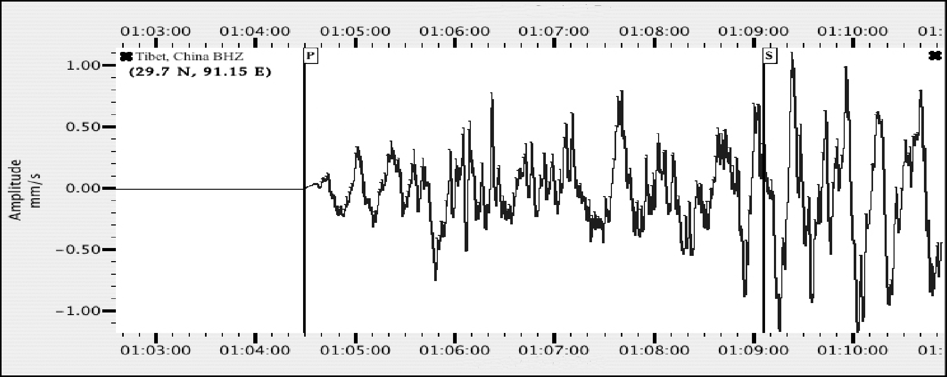
IC.LSA (Tibet, China): Latitude:29.7 N, Longitude:91.15 E
http://www.fdsn.org/station_book/IC/LSA/lsa.html
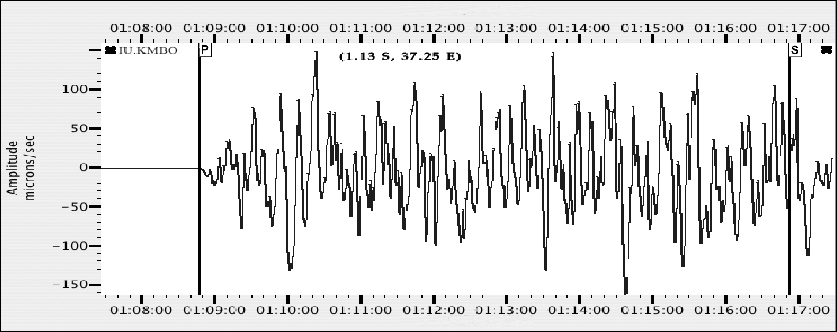

KMBO Latitude: 1.13 S, Longitude: 37.25 E
http://www.fdsn.org/station_book/IU/KMBO/kmbo.html
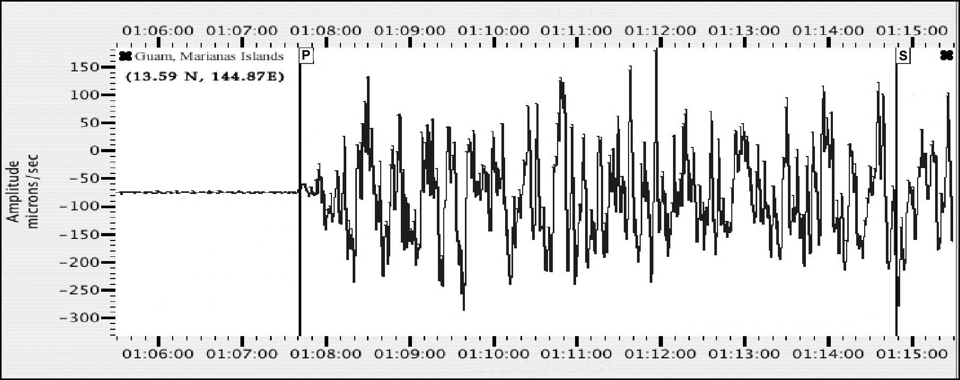

GUMO - Guam, Mariana Islands Latitude: 13.59 N, Longitude: 144.87 E
http://www.fdsn.org/station_book/IU/GUMO/gumo.html

Maps and Charts
P- and S-Waves Travel-Time Curves

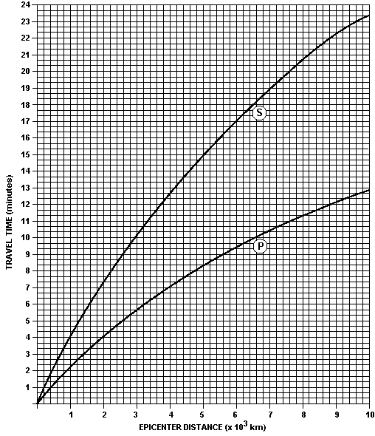

(Chart from the New York State Earth Science Reference Tables)
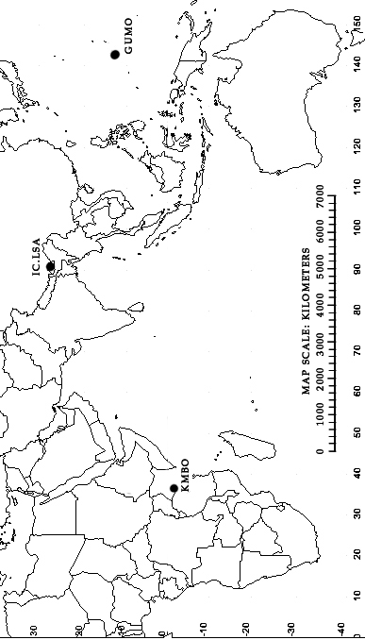
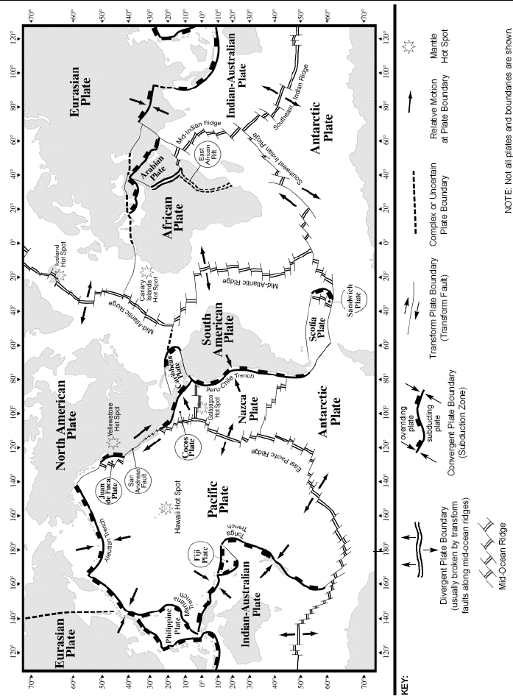
Maps and Charts
SEISMOGRAPHS for Part 2
http://ida.ucsd.edu/IDANetwork/index.html
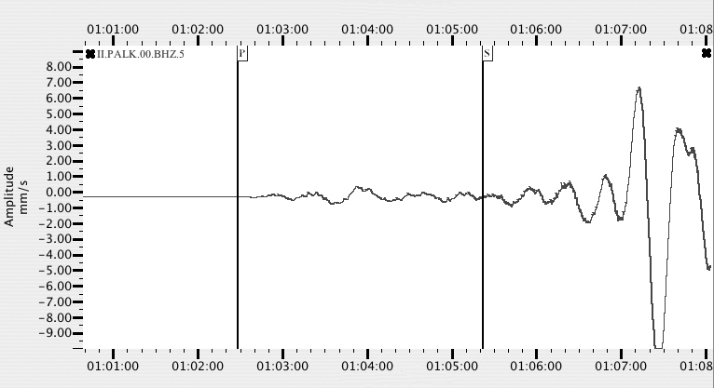
PALK, Pallekele, Sri Lanka: Coordinates: (7.3° N, 80.7° E)
http://ida.ucsd.edu/Stations/palk/index.html
http://ida.ucsd.edu/public/II/PALK/palk.html

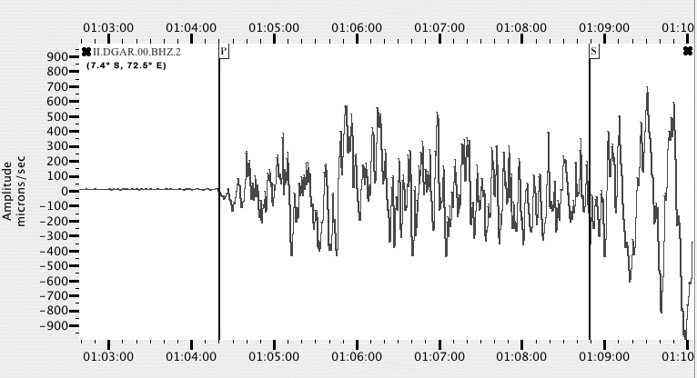
DGAR, Diego Garcia, British Indian Ocean Territory: Coordinates: (7.4° S, 72.5° E)
http://ida.ucsd.edu/Stations/dgar/index.html
http://ida.ucsd.edu/public/II/DGAR/dgar.html
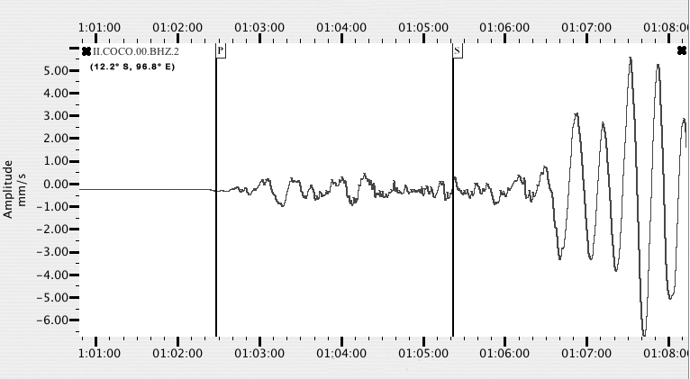
COCO, Cocos (Keeling) Islands, Australia: Coordinates: (12.2° S, 96.8° E)
http://ida.ucsd.edu/Stations/coco/index.html
http://ida.ucsd.edu/public/II/COCO/coco.html

