- Rick and Carl come across an abandoned bowling alley. Rick has an 8.0 kg ball and rolls it at 2.0 $m/s$ toward a 12 kg bowling ball at rest. If the 12 kg ball has a final velocity of 1.5 $m/s$, calculate the velocity of the 8.0 kg ball. What type of collision is this?

- Use conservation of energy to fill in the blanks for the diagram below. Show all of your work!
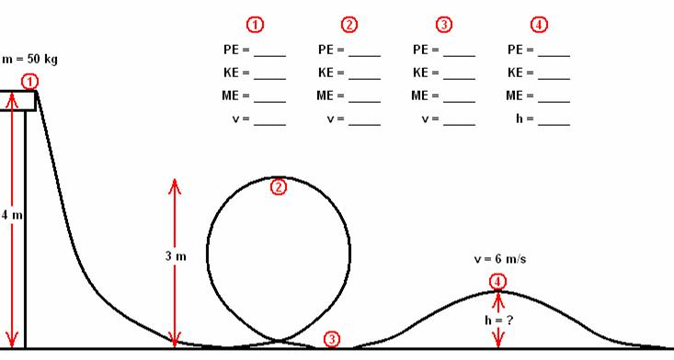
- Daryl finds an old ballistics lab and decides to have some fun with physics. The muzzle velocity of guns (the velocity of the bullet right as it leaves the gun) can be found by firing the bullet into a massive block of wood on a frictionless surface and measuring the final velocity of the block.
  - What type of collision is this?
  - Given that the mass of the bullet is 13 grams, the mass of the block is 4.0 kg and the final velocity of the block with the embedded bullet is 1.2 $m/s$, find the initial velocity of the bullet.
  - What is the magnitude of change in momentum experienced by the bullet just after impact?
  - If the bullet slows to a stop in 0.090 seconds, what is the magnitude of average force on the bullet?
  - Describe how momentum and energy are conserved in this situation?

- A 1200 kg car is crash-tested against a rigid wall. The car is accelerated by a cable underneath it, which provides a constant force of 5$0$0. N for a distance of 15.0 m.
- What is the velocity just before it hits the wall?
- The car’s “crumple zone” crumples 2.30 m upon impact. What is the force the car experiences upon impact?
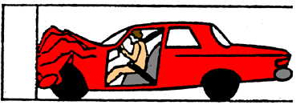

- Glenn remembers when he was in spring training! His favorite memory is about his first homerun! The ball was pitched at 45 $m/s$ and he swung his bat with an initial speed of 31 $m/s.$ After the bat and the ball collided, the ball left the bat at homerun velocity, 67 $m/s$. The time of contact was 0.0015 sec. The mass of the bat was 1.0 kg and the mass of the ball was 0.14 kg.
- What was the change in momentum of the baseball?
- What was the force of impact of the bat against the ball?
- By how much was the bat slowed down by the impact?

- Maggie is looking to play a trick on Beth by dropping a water balloon on her head. Her plan is to climb a tree, sit on a branch and drop the water balloon as Beth walks underneath. Sounds good, huh?
- If she carries this 0.75 kg balloon up a tree 15 m vertically, how much work has she done to the balloon?
- When Maggie drops the balloon on Beth’s head (approximately 2.0 m above the ground), how fast will the balloon be traveling? (Hint: Use energy equations!)
- If Beth thinks quick, dodges and catches the balloon with a downward motion of her hands, such that she exerts a constant force on the balloon for 0.30 seconds, what is the magnitude of this force? (Hint: think impulse!)
- Why would the balloon break if it hit Beth’s head, but probably not if she caught it with a downward motion? Use appropriate physics terminology in your answer.

