- Define and provided examples for the following types of waves:
  - Transverse: waves with particle motion perpendicular to wave propagation (i.e. – guitar strings, earthquake S-waves)
  - Longitudinal: waves with particle motion parallel to wave propagation (i.e. – sound waves, earthquake P-waves)
  - Surface: waves with particle motion perpendicular AND parallel to wave propagation, resulting in a circular motion (i.e. – water waves)

- What is the only factor that affects the speed of a mechanical wave?
Wave speed is a property of the medium through which the wave is travelling.

- Define and list the variables for the following terms:

  - Frequency: The number of complete cycles that pass a fixed point every second; units: Hertz (Hz)
  - Period: The amount of time required to complete on full cycle; units: seconds (s)
  - Wave Speed: The speed with which energy propagates through a medium; units: ^{m}/_{s}
  - Amplitude: For transverse waves: amplitude is a measure of maximum displacement from equilibrium. In longitudinal waves: it is the difference in pressure between the compressions and rarefactions (perceived as volume in sound waves).
  - Wavelength: The distance from one point on a wave to the same point on the next wave (i.e.- crest to crest); units: meters (m)
  - Sound Intensity: power of sound per unit areas; units: decibels (dB)

- Sketch and label the following diagrams:
  - Transverse Wave:
Crest
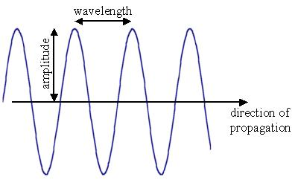

Trough

  - Longitudinal Wave:
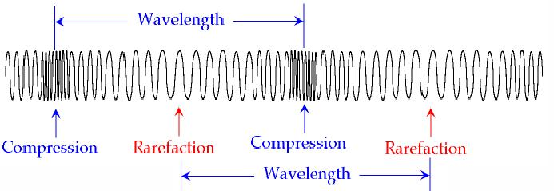

- Define and sketch a diagram for each of the following wave behaviors:

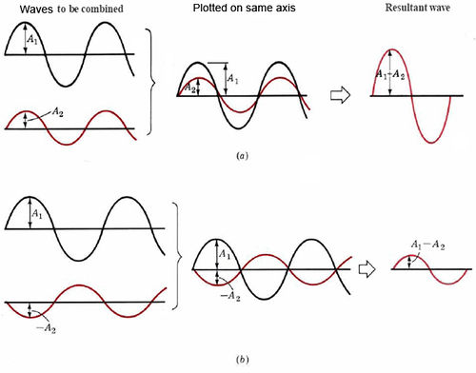
  - Constructive Interference

  - Destructive Interference

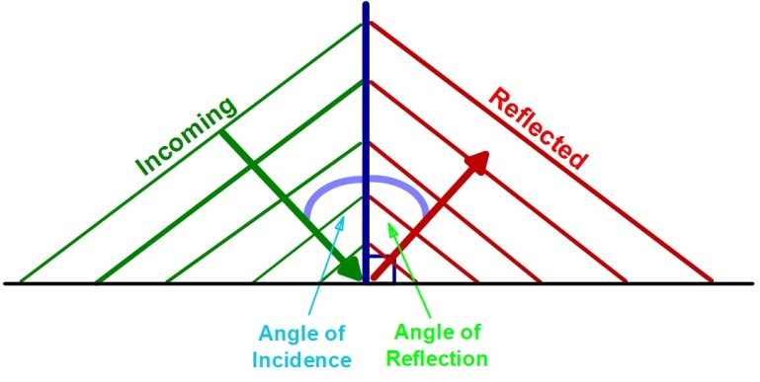
  - Reflection

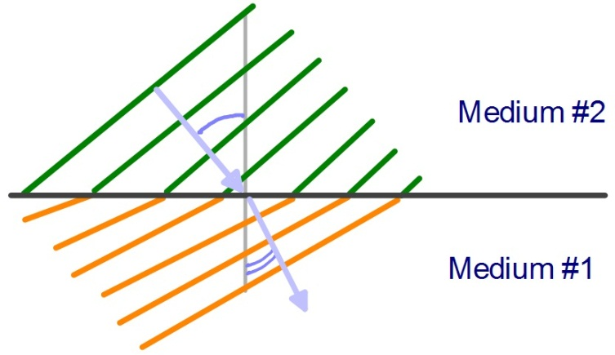
  - Refraction

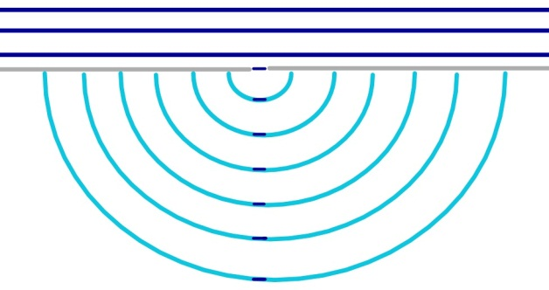
  - Diffraction

- What is the superposition principle? What does it mean for mechanical waves?
The superposition principle states that waves can be in the same place at the same time. To find the resultant wave’s amplitude, we simply add the two waves point by point.

- Define the following:

  - Primary Waves: longitudinal waves that arrive first during an earthquake
  - Secondary Waves: transverse waves that arrive second during an earthquake
  - Epicenter: the point on the earth’s surface directly above the focus
  - Focus: the point where the earthquake occurs
  - Earthquake: a sudden movement occurring to release stress that builds up between plate boundaries
  - Tsunami: long sea waves that travel up to 1000 km/hr with very long wavelengths

- What are the events that can cause earthquakes? Tsunamis?
Earthquakes can be caused by tectonic activity, volcanic activity, or large shifting masses.
Tsunamis can be caused by earthquakes causing tectonic displacement, volcanic eruptions causing seismic activity, landslides above or below water, or asteroids (very rare).

- What are the 3 types of plate boundaries we learned about? How do plates move relative to each other with these types of boundaries?
At divergent boundaries, plates are moving away from each other. At transform boundaries, plates move past each other. And at convergent boundaries, the plates are coming together. (Ocean meeting continental = subduction zone; Continental meeting continental = mountain)
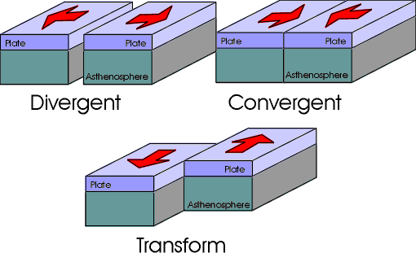

- How do seismographs work?
This can vary by design; HOWEVER, the basics are the same. The main housing of the seismograph is fixed to the earth, so it will shake with seismic activity. The recorder is attached to a free hanging object. The inertia of the recorder keeps it from moving with the housing, thus recording the movement of the earth due to the seismic waves!

- What’s the difference between a water wave and a tsunami?
Water waves have circular motion where tsunamis do not. This means that water waves will crest and break in shallow water. Tsunamis, on the other hand, keep building amplitude and run quickly inland like a wall of water.

- Why do the amplitudes of tsunamis increase as they approach the shore?
The shallower water acts as a different medium, which slows down the water in front. The back of the wave is still moving quicker, so it builds up, thus increasing the amplitude (like a traffic jam).

- Define pitch; what wave property is it most closely related to?
Pitch is the tone of a sound (how high or low something sounds). It is most closely associated with frequency.

- Define loudness; what wave property is it most closely related to?
Loudness is the brain’s interpretation of pressure differences in sound waves. This is related to the amplitude of the sound wave.

- If frequency changes, what other wave properties are changed? Are they directly or indirectly related?
If frequency changes (and the medium is not), the period changes inversely (i.e. – if frequency increases, period decreases), as does the wavelength (also inversely).

- How does air temperature affect the speed of sound? List an equation to support your reasoning.
Yes! Sound travels faster in warmer air because the molecules have more kinetic energy and are thus easier to propagate through.
$$v_{sound}=331+0.6T$$

- Explain how the following parts of your ear are related to your ability to hear:

  - Eardrum: The eardrum vibrates when sound waves reach it; these vibrations are then carried as pressure waves to the middle ear.
  - Hammer: The hammer is a small bone in the middle ear; it vibrates due to pressure waves from the eardrum.
  - Anvil: The anvil is a small bone in the middle ear; it vibrates due to vibrations from the hammer bone.
  - Stirrup: The stirrup is a small bone in the middle ear; it vibrates due to vibrations from the anvil bone. It then transmits pressure waves to the inner ear.
  - Cochlea: The cochlea has tiny hairs connected to nerve receptors. These hairs vibrate due to the pressure wave created by the bones in the middle ear. These hairs create electrical impulses that are sent to the brain and interpreted as sound!

- Define the following terms:

  - Infrasonic frequencies: frequencies LOWER than 20 Hz
  - Ultrasonic frequencies: frequencies HIGHER than 20,000 Hz
  - Subsonic speeds: speeds SLOWER than the speed of sound (~343 ^{m}/_{s})
  - Supersonic speeds: speeds FASTER than the speed of sound

- Define the Doppler Effect. How does the apparent frequency shift for an observer based on the motion of the source?
The Doppler Shift is the APPARENT shift in frequency due to the relative motion of a sound source to an observer. When the source is moving TOWARDS the observer, the pitch the observer hears will be HIGHER than the source frequency and vice versa!

- A tuning fork with a frequency of 480 Hz is played in a room with a temperature of 25°C.
  - What is the period of the sound wave?
$$f=\frac{1}{T}↝T=\frac{1}{f}=\frac{1}{480 Hz}$$
$$\boxed{T=0.00208 s=2.08×{10}^{-3}s}$$

  - What is the velocity of the sound wave produced?
$$v_{sound}=331+0.6T=331+0.6\left(25℃\right)$$
$$\boxed{v_{sound}=346m/s}$$

  - What is the wavelength of the resulting sound wave?
$$v=fλ↝λ=\frac{v}{f}=\frac{346m/s}{480 Hz}$$
$$\boxed{λ=0.721 m=721 mm}$$

- The velocity of the primary waves produced by an earthquake is 8900 $m/s$ and that of the secondary waves is 5100 $m/s$. A seismograph records the arrival of the transverse waves 74 s after the arrival of the longitudinal waves. How far away is the earthquake?
$$d=v∙t$$

$$d_{p-wave}=v_{p-wave}∙t_{p-wave}$$
$$d_{s-wave}=v_{s-wave}∙\left(t_{p-wave}+t_{delay}\right)$$

$$d_{p-wave}=d_{s-wave}$$
↓
$$v_{p-wave}∙t_{p-wave}=v_{s-wave}∙\left(t_{p-wave}+t_{delay}\right)$$
↓
$$\left(8900m/s\right)∙t_{p-wave}=\left(5100m/s\right)∙\left(t_{p-wave}+74 s\right)$$
$$\left(8900m/s\right)∙t_{p-wave}=\left(5100m/s\right)∙t_{p-wave}+377,400 m$$
$$\left(3800m/s\right)∙t_{p-wave}=377,400 m$$
$$\underline{t_{p-wave}=99 s}$$
↓
$$d_{p-wave}=v_{p-wave}∙t_{p-wave}=\left(8900m/s\right)∙\left(99 s\right)$$
$$\boxed{d_{p-wave}=883,911 m=883 km}$$

